# Durable Furnitures

Noir

## Modern Farmhouse Walnut Tractor Seat Counter Stool

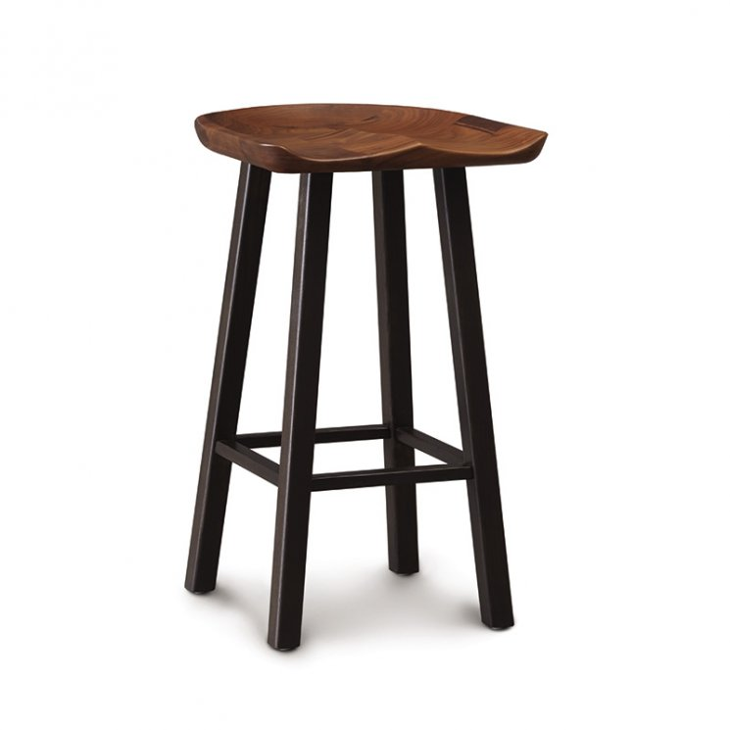

The conforming scooped seat design of Copeland's Tractor Seat Counter Stool gives dining comfort a whole new meaning for the modern home. Handcrafted in solid natural walnut wood, the seat rests atop four slightly splayed seared ash wood legs creating a durable seat with a designer vibe. This stool will look fantastic paired with your kitchen island or with Copeland's matching Modern Farmhouse Counter Height Farm Table in Walnut. Add an extra touch of contemporary style and comfort to your home with a set of Tractor Seat Counter Stools of your own.